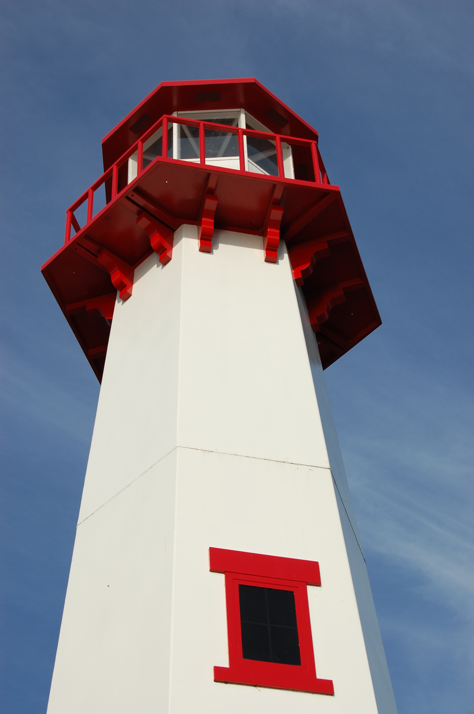
THE LIGHTHOUSE

Newsletter for April 2017

The sun will no more be your light by day, nor will the brightness of the moon shine on you, for the LORD will be your everlasting light, and your God will be your glory. Isaiah 60:19

Message from Our Pastor

Dear Sisters and Brothers in Christ,

Alleluia! Christ is risen!
Christ is risen indeed. Alleluia!

I love hearing this proclamation of the good news. It warms my heart and gives me hope. It also brings back good memories because it was the first proclamation of the good news I proclaimed on my journey in ministry! The story goes like this, it was on Good Friday of 2002. I felt the call to ministry, and after a very long discussion with my Pastor that afternoon, three days later on Easter morning I found myself in a white robe shouting out to my home congregation those beautiful words!
This month at Zion and Trinity, the celebration of the resurrection of our Lord Jesus Christ drowns out everything else. As well it should. Not only does the resurrection of Christ prove that his sacrifice on Good Friday was accepted by God the Father, but it demonstrates the power Jesus has over death. No longer do people need to live in fear that they will cease to exist at the moment of death.

The resurrection of Christ shows that there is life after death. As Christians we believe that, because in baptism we have been connected to Christ in his death, we will be connected to him in his resurrection (Romans 6:3-5). We believe that what happened to Jesus is happening and will happen to us. The message of the cross and empty tomb has always been the most important message anyone could ever hear.
But especially in these times of doubt, of hopelessness and of unprecedented worry and angst, the message of Jesus’ resurrection needs… NEEDS to be heard! Just as the resurrection of Christ drowns out everything else we are doing as a church in the month of April, as Christians it should drown out everything else when we tell others what we believe and the hope that we have. God’s richest blessings to you as you celebrate the defeat of death and the guarantee of salvation: the resurrection of our Lord Jesus Christ!
Alleluia! Christ is risen!
Christ is risen indeed. Alleluia!

Yours in Christ,
Pastor David

Newsletter

The April Newsletter was adopted by Marialana Nygard


In loving memory of
Jack Nygard

Noisy Offering

The noisy offering for April 2nd will go to ELCA Malaria Campaign.

Sunday School

We will have Sunday School for all children, Preschool – 5th grade, during the 11 am service at Zion (except for the last Sunday of the month).

Zion Women’s meeting

We will have the monthly women’s meeting at noon on April 2nd.

Adult Bible Study

Adult Bible Study at Trinity will be Tuesdays at 6 pm.

Adult Bible Study at Zion will be Wednesdays at 7 pm starting after Easter. Please join us in the Zion Family Center!
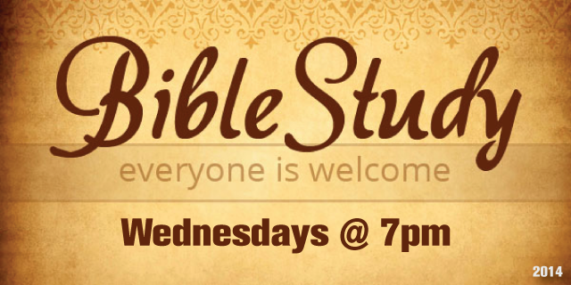

Confirmation

There will be Confirmation Class on April 9th from 5 -6:30 pm.

Palm Sunday Pancake Breakfast

Zion will be hosting a pancake breakfast on Palm Sunday from 8 to 11 am. We will be providing sausages, beverages and all-you-can-eat pancakes. We will need helpers to set up, fix the food and clean up afterwards. The money will go toward the church.

Lenten/Easter Services

There will be Lenten worship at 7 pm on April 5th at Zion Evangelical Lutheran Church as well as on Maundy Thursday (April 13th).

On Good Friday (April 14th) there will be a service at noon at the United Methodist Church.


At 6 am on Easter Sunday there will be a Sunrise Service at Trinity.


The 11 am Easter Service at Zion will be followed by an Easter egg hunt.

Wedding Anniversaries

Matt & Loni LaJoice April 13

April Birthdays

Emma Feleppa 1
Merlin Doran 2
Jim Rose 3
Skyler Music 6
Barb Lehto 7
Susan Fenlon 8
Morgan LaVake 8
Nadine Dandona 14
Benjamin Lennington 14
John Kennedy 14
Andrew Sjogren 15
Jacob Sjogren 15
Helena Kissinger-St. Onge 17
Sharon Chalmers 17
Denise Maxson 18
John Chambers 20
Shannon Martin 20
Sybil Swadling 24
Jeni Therrian 24
Nicole Coveyou 25
Cooper Johnston 25
Don Kallstrom 25
Sarah Doran 27
Devan Harju 27
Rebecca LaLonde 30

Baptismal Anniversaries

Toni Johnston 2
Marion Hill 3
Kyle Elmblad 3
Wyatt Huhn 4
Chase DeKeyser 8
Logan DeKeyser 8
Danielle Ford 8
Nicole Elmblad 11
Bonnie Bergeron 11
Matthew Valetta 11
Adam Chambers 15
Tyler Chambers 15
Brian Harju 15
Devan Harju 15
Jody Harju 15
Luke Valetta 15
Judy Massey 17
Gracia St. Andrew 17
Marlene Olsen 19
Becky Paul 19
Cierra Barker 20
Savannah Barker 20
Noah Mathew Huhn 20
Micah Gaubault 21
Dan Spencer 21
Preston Spencer 21
Shannon Huhn 22
Tammy Shepard 23
Bailey Ryerse 24
Donovan Insley 25
Mike Lehto 26
Merlin Doran 28

Congratulations! & Thank You!

Congratulations to Pega Kennedy for winning the Mac-n-cheese Bake Off! Thank you to all the participants (those who entered their creations and those that taste-tested them all)! The Youth Group is grateful for the money raised toward their trip to Houston.

April Showers of Song

On April 29th from 5:30 – 7:00 pm, Zion Lutheran in Allenville is having their annual fund raiser for the ELCA Youth trip in 2018. $10 will get you baked ziti, salad, garlic bread, dessert and beverage! There will also be music, a sing-a-long, fellowship and a bake sale.

Winsome Women

2017 Christian Retreats at the Grand Hotel on Mackinac Island. Theme: Shaped by the Potter

Isaiah 64:8b “We are the clay, you are the potter.”

May 16 & 17 , Tuesday & Wednesday
May 17 & 18, Wednesday & Thursday
May 18 & 19, Thursday & Friday

To register, go to www.wswretreats.org beginning March 4th at 8:30 am. This is an invitation to a day and a half retreat where you will join with other women for fellowship, encouragement and inspiration as God’s love comes alive. Two night stay available, see detail on website.

Prayer List

(If you would like someone added to the prayer list, please call or email the church)


Mary Belonga, Dave & Lois Movalson, LaTaunya Paquin, Barb Lehto, Charlie Lamoreaux, Bev Kammers, Joe & Sharon Chalmers, Nadine Dandona, Patty Thibault, Jim Rose, Karen Fowler, Delores Marshall, Bill & Sandy Tielbar, Linda Wilkins, Bill Anderson, Karen Kammers Sparks, Joel Morabito, Rick Brown, Eric Rose, Jackie Kallstrom, Ingrid Thompson, Kathy Essary, Russell Winberg, Tom & Taffy Coffey, Charlie Doud, Bishop Skrenes, Richard Galor, Josh Feleppa, Charles Beeck, Sarah Marolf, Mike Herman, Eunice Therrian, Wes Pechta, Sonja Brown, Lou Hitts, Jack Dyer, Fred Dandona, Rick Weiss,, Toni Leny, Suzie Nestberg and the family and friends of Barb Trainor-Hoyt

Trinity Worship Families

Apr 2 Baron Family
Apr 9 Chalmers Family
Apr 16 Rose Family
Apr 23 Kennedy Family
Apr 30 Movalson Family

Zion Funeral Committee April-June

Team Leader: Lana Lennington (643-6576)
Co-leader: Lorraine Graham (643-8419)
Servants for Zion

Ushers & Greeters
April 2 Confirmation Youth
April 9 LaJoice Family
April 16 Dena Barker & Donna Harju
April 23 Martha Sjogren & Tracey McCluskey
April 30 Lana Lennington & Family

Lectors
April 2 Paul Shepard
April 9 Judy Ryerse
April 16 Lynn Evans
April 23 Lorraine Graham
April 30 Rita LaVake

Acolytes
April 2 Bailey Ryerse
April 9 Brendan Insley
April 16 Ellie Tielbar
April 23 Josh Feleppa
April 30 Matthew Valletta

Communion Assistants
April 2 Steve Christiansen
April 9 Dena Barker
April 16 Lorraine Graham
April 23 Karen Schlehuber

Altar: Lorraine Graham
Money Counters: Lana Lennington & Dena Barker

The Usher duties are:
- Arrive 30 minutes before church
- Pass out bulletins and welcome guests
- Help with the offering and communion
- Record attendance
Council Meetings

Trinity Council Meeting, April 18^{th -} 6 pm
Zion Council Meeting, April 19th - 6:30 pm

Zion’s Council Members
President: Steve Christiansen 298-1051
Vice-President Karen Schlehuber 643-0311
Co-Treasurers: Dawn Akers 643-7552
Co-Treasurers: Lana Lennington 643-6576
Secretary: Lorraine Graham 643-8419
Mary Christiansen 235-6123
Robert Marshall 643-8936
Dena Barker 430-1460
Paul Shepard 984-2069

Trinity’s Council Members
President: Jerri Rose 292-5570
Vice-President Sharon Chalmers 292-5440
Secretary: Tracy Movalson 292-5581
Treasurer: Pega Kennedy 292-5633
Co-Treasurer: Jim Rose 292-5570
Financial Secretary: Tom Gustafson 292-5460
WELCA: Pega Kennedy 292-5633
John Kennedy 292-5633
Lois Movalson 292-5581

Treasurer's Report for Zion
January 1, 2017 through March 18, 2017
Income:
 | Amazon Smile Foundation | 6.38
 | Church Use Income | $ 75.00
 | General | $ 10,159.11
 | Fund Raising - Soup Luncheon | $ 1,326.70
 | Trinity Share | $ 3,748.73
 | TOTAL |  | $ 15,315.92
Expenses:
 | Administration | $ 593.48
 | Benevolence | $ 276.62
 | Church Maintenance | $ 2,372.72
 | Education | $ 374.90
 | Parsonage Maintenance | $ 879.75
 | Pastoral | $ 9,960.72
 | Worship | $ 643.06
 | --To Building Fund | $ 0.00
 |  |  | $ 15,101.25
 |  |  | 214.67
***********************************************************
Thrivent Financial Investment Fund |  |  | $ 288.07
General fund balance: |  |  | $ 866.82
Kitchen/Building Fund balance |  |  | $ 2,092.90
General fund owes building fund: |  |  | $ -
General fund owes Mission Endowment fund: |  |  | $ 7,995.00
Zion Lutheran Council Meeting
March 20, 2017

Council Members Present: Steve, Mary, Robert, Lorraine, Dawn and Pastor Dave

Steve called the meeting to order at 6:40 pm.

Pastor Dave opened with devotions from “Daily Read from Martin Luther”

1. Pastor's Report:

A. Pastor mentioned his visitations
B. He will be scheduling a stewardship meeting
C. He would like to see if there is any interest in starting a “Walking with Pastor” group
D. He would like to see if there is any interest in starting a “Men’s Breakfast Group”
E. The Council Commissioning will be on Palm Sunday

2. Treasurer's Report:
Treasurer's report was discussed and approved.

3. Secretary's Report:
Secretary's Report was approved as printed in the last newsletter.

4. Old Business:

A. Robert reported on the progress he and Jerry are making with the elevator
B. Robert said he would get an estimate on putting eave troughs on the back of the church. He also mentioned he had a tub for water collection for the Pastor’s garden if he wanted it.

5. New Business:

A. The last Soup Luncheon raised $576 for the church
- The Mac-n-Cheese Bake-Off raised $260 for the Youth Group Trip.
- Next Month’s Council meeting will be on April 19th
- A Boy Scout’s Group will be staying at the church on April 28th and 29th
- We will be confirming two students on Pentecost (June 4th)
- There was discussion on if we had Seniors graduating this year.

Meeting was adjourned with the Lord’s Prayer at 7:20 pm.

Respectfully Submitted,
Lorraine Graham

Trinity Annual Meeting Minutes
January 29, 2017

Present: Pastor Dave, Jerri & Jim Rose, Pega & John Kennedy, Tom & Joyce Gustafson, Joe Chalmers, Lois & Tracy Movalson

Pastor led the meeting in prayer. Meeting commenced at 4:53pm

Minutes from 2016 Annual Meeting were read and approved.

Pastors Report: Celebrating 1 year and 6 months with our congregation! Our Midsummer Pole Raising in June and Community Dinner in December were memorable events showing how we serve our community. Participation in the Annual Toy Drive and Food Drive more ways we serve. Wednesday Night Bible Studies are popular and a great way to join in fellowship. Pastor Dave is happy with our growing ministry. Pastor is working on creating a website for both churches and Cathy Tielbar will administer both Facebook pages for the churches. Creating a “come and see program” sign for the churches.

Presidents Report: Review of events…Easter Sunrise Breakfast was well attended as was Midsummer Pole Raising and December Community Dinner. Summer attendance was excellent and we made new friends.

WELCA Report: Highlights of service include; assisting with Easter Breakfast, Feeding the Lions Club twice, Volunteering at Hope Chest, and helping with Lay School. No funerals for 2016!

Budget was proposed and approved.

Investments will be discussed at next meeting.

Benevolence amount to Synod was discussed and Council approved.

Tom Gustafson and Joe Chalmers will be audit committee.

Synod Assembly is May 21-23, 2017.

Meeting adjourned at 5:35 PM
Submitted By Tracy Movalson, Secretary

Trinity Council Meeting Minutes
March 21, 2017

Present: Pastor Dave, Jerri & Jim Rose, Pega & John Kennedy, Tom Gustafson, Sharon Chalmers, and Tracy Movalson

Pastor led the meeting with a reading from Luther’s Writings, 10 Sermons on Catechism. Meeting commenced at 6:20pm

Pastors Report: Pastors activity includes; 2 hospital visits, 10 home visits, and 3 phone visits. Pastor wants to start a coffee get together in the community. Worship this week on Sunday is “Thanksgiving for Baptisms”. Ray Baron is building a removable rail for the communion rail.
Mac Cheese cook off is this Sunday!

Secretary’s Report was read and approved.

Treasurer’s Report was read and approved.

Financial Secretary’s Report was read and approved.

Old Business:
Still need to scan Church Records.

New Business:
Easter Sunrise is 6:52am. We will start service at 6:00am. Try to have it on the beach?

Synod Assembly May 21-23, 2017. Tracy Movalson and Jerri Rose will attend. New Bishop will be elected. Held at NMU in Marquette. Theme is “called”. Register online. Reminder take collected money for world hunger in paper currency.

Jerri asked if a microphone would be something we could use for Sunday Services.

We still have money left from prepaid heating fuel.

Pega asked that the last 3 noisy offerings go to Zion Youth Group Trip. Tom motioned to approve, Sharon seconded. Voted approved.

Correspondence: thank you letter from Food Pantry.

Sharkey Memorial funds: It was suggested that we engrave a mall for midsummer pole with Sharkey’s name on it.

Meeting adjourned at 7:09 PM
Respectfully Submitted By Tracy Movalson, Secretary

Contact Information

Pastor David Tielbar may be reached at 906-984-2051 or at david.tielbar6@gmail.com. In an emergency, you can reach the Pastor’s cell phone at (563) 880-4512

Church telephone: 906-643-7870 - Answering machine
The secretary will usually be in the office on Tuesday and Thursday mornings from 9 – 12

To email the church is: ziontrinity950@yahoo.com
The website is at http://zionstignace.com/home.html
- Find us on facebook at www.facebook.com/zionstignace

Zion Evangelical Lutheran Church and Trinity Lutheran Church are congregations of the Northern Great Lakes Synod and the Evangelical Lutheran Church in America.

Trinity’s Sunday Service is at 9 a.m.
Zion’s Sunday Service is at 11 a.m.

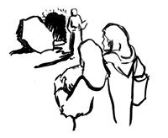

He is risen!
Share the good news!

2017 Easter Lilies Given By:
The Aker, Doran &  Schlehuber families | In memory of Ramona Beeck Akers
Lynn Evans | In memory of James Morand
Eunice Therrian | In memory and honor of loved ones
Donna B. Harju | In memory of Charles Harju
Hilda & Jim Ryerse | In memory of our parents
Richard Galor | In memory of my wife
Lois Movalson | In memory of Sharky  In memory of Pam & Chrissy Movalson
Pastor Tielbar  & family | In memory of Pastor Lewis Thompson
Betsy & Alan Turf | In memory of our parents  In honor of our children
The Public is invited to the

Palm Sunday
Pancake Breakfast



April 9, 2017
8:00 a.m. – 11:00 a.m.

ZION LUTHERAN CHURCH
ST. IGNACE

Pancakes, sausage and beverage
Suggested donation: $5.00

Help Cheboygan County Sheriff’s Department get new defibrillators. Go to Heartsmart.com’s Facebook page.
Like them. Make the comment “Cheboygan County
Sheriff’s Department Shock for Life”

Help raise money for Zion Evangelical Lutheran Church of St. Ignace. When buying from Amazon first go to Smile.Amazon.com and set it up to donate .5% of the price of any purchases to go to Zion Evangelical Lutheran Church of St. Ignace.

